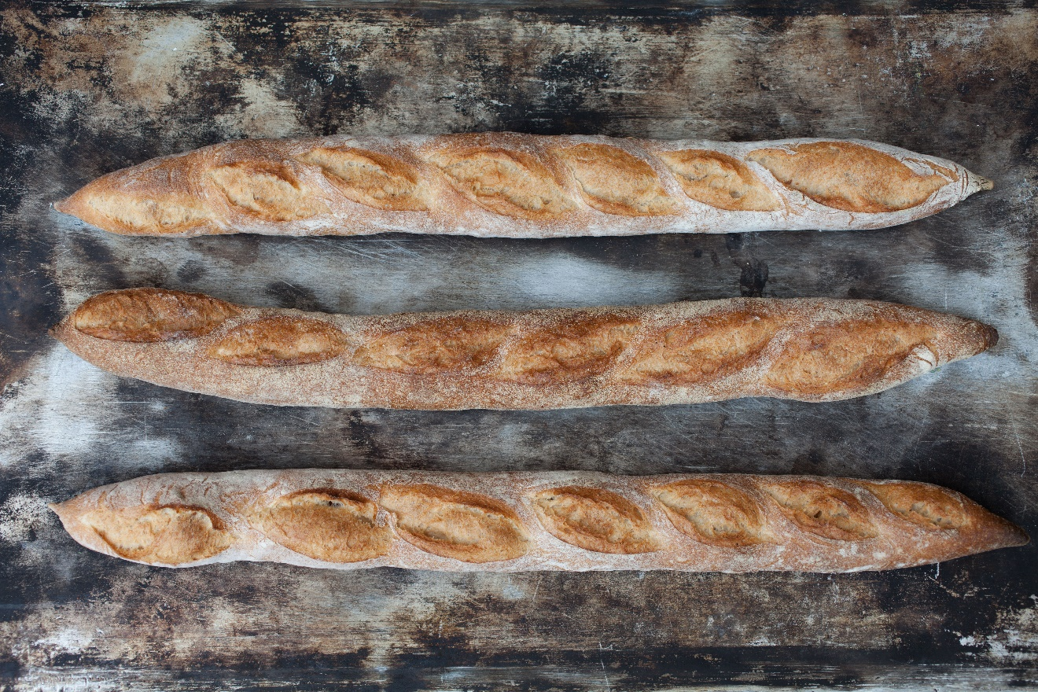

Bread Charity

Design, Evaluation and Development

Toddles Aeon | WEB701 Web Technology | Date

# Executive Summary/ Abstract

Contents

Executive Summary/ Abstract 1

Designing the website. 3

Website Brief 3

What are the Website requirements? (using Information Architecture analysis) 4

Site Goals 4

Define the User experience 4

Site Content 4

Site Structure 5

User Stories – Designing to build 6

CRUD analysis – API prototype 6

Evaluating web technology – which to use.? 7

Developing the website 8

# Introduction

# Designing the website.

## Website Brief

Charity is to supply students with school supplies.

The (Charity Name) charity is a charity that will offer school supplies to students/families within the Nelson community.

The (Charity Name) charity will let providers register and list the products they are providing. They will also have the possibility of working with schools in the Nelson region to get the supplies to the students that need it.

The following features will be needed:

- Elements that engage the user.

- Providers can register and state what items they are supplying.

- Members of the community can view what supplies are available and also sort by type.

-

The members of the <charity> are interested in having a website of their own. The following is brief description on the proposed website:

|  |
| --- |
| The <charity name> Charity are is a “food bank style” charity in the Nelson region who offer their <product name/or service name> to the local community.  We need a website for the Nelson region for members of the charity to provide <products/or services>.  The purpose of the new website is to help with the distribution of the service or product by members of our charity to customers. Like a “food bank”, the website lets members register and describe the service or products they are providing, the number and frequency of the offerings.  The website lets members of the community (beneficiaries) access the service, by providing tokens that can be “spent” in the service. To achieve our goal, we would like to have an online token function on our website that let a beneficiary access a limited number of tokens, for example the system needs a mechanism that verifies that a member of the community is accessing the service and that the token belongs to a particular community member. The website needs some homepage text about general information of our products and services such as: types, characteristics, quality factor, usage and benefit.  We require the following features on the website:  1.   Charity members and beneficiaries can register, log in and administer their own accounts.  2.   Members use the website to register their products and services, and beneficiaries use the system to acquire tokens.  3.   Interactive element(s) that engages the website user.  4.   The system provides an interface that the members can use to [accept](https://ecampus.nmit.ac.nz/moodle/mod/glossary/showentry.php?eid=9771&displayformat=dictionary) a token in a transaction. |

## What are the Website requirements? (using Information Architecture analysis)

### Site Goals

One short paragraph introducing the site goals.

#### Mission or purpose of the website.

#### Short- and long-term goals.

#### Intended audiences (a brief overview)

#### Why will people come to the website?

### Define the User experience

One short sentence that introduces the desired experience for users of the website.

#### The Audience

##### First type of audience

##### Second type of audience.

##### Continue until all have been listed and briefly described.

#### Scenarios and Personas

Write 3 to 4 short scenarios that describe how the website is going to used. Write “grungy” persona descriptions.

#### Competitive Analysis

Look for and write about other websites like your one, e.g. charity and goods distribution websites. At least three, best would be five. For each website write about their functional and visual layout. What do they have in them that is useful, and what is not useful? Write a summary of the requirements you have discovered

### Site Content

#### Content and Functional requirements

Write a summary of the required content of the website and list the Functional requirements.

Content includes written text, images, forms, navigation within the website. Functional requirements are identified in the brief.

#### Group and Label your Content

Use a number of “stickies” or a whiteboard to represent the content in your website. Oragnise that into groups and potential “hierarchies”

### Site Structure

#### Metaphors

Write a brief definitional of :

Organisational metaphor

Functional metaphor

Visual metaphor

#### Site structure listing

Write a text based hierarchical listing of your website. This should come from your Grouping and Labeling work.

#### Architectural “blue print”

Create a graphical diagrammatic map of the site, that includesnavigation links, e.g. a Visual representation of the site’s structure

#### Define navigation

In your diagram indicate Global navigation and Local navigation.

#### Visual Design

Create a series of layouts (in grid format), that depict parts of the website.

Mock up webpages – design sketches.

## User Stories – Designing to build

From your previous information architectural analysis , extract a series of User Stories, to be used in an Agile process. Your Scenarios and Functional requirements can guide your in this. Read here

<https://www.atlassian.com/agile/project-management/user-stories>

Write a list of features – this is actually identified in your previous analysis, from the “Blue Print” site structure diagram.

Create a “backlog list” of features (and tasks) you need to do to build the website.

### CRUD analysis – API prototype

Produce a CRUD table – details to come, that lists the proposed INSERTS (creates) , RETRIEVALS, UPDATES and DELETIONS of data required in the implementation of your website.

Create an API that implements these for your website. At least with testable “mockups”. of functionality,

# Evaluating web technology – which to use.?

# Developing the website – about web technology

# Summary and Conclusion

# References

APA 7 style citations and referencing throughout this report.